**This Article covers:**

* Three main different types of machine learning.
* The difference between labelled and unlabelled data.
* What supervised learning is and what it’s useful for.
* The difference between regression and classification, and what are they useful for.
* What unsupervised learning is and what it’s useful for.
* What reinforcement learning is and what it’s useful for.

As we learned , machine learning is common sense, but for a computer. It mimics the process in which humans make decisions based on experience, by making decisions based on previous data. Of course, this is challenging for computers, as all they do is store numbers and do operations on them, so programming them to mimic human level of thought is difficult. Machine learning is divided into several branches, and they all mimic different types of ways in which humans make decisions. In this chapter, we overview some of the most important of these branches.

ML has applications in many fields. Can you think of some fields in which you can apply machine learning? Here is a list of some of my favorites:

* Predicting housing prices based on their size, number of rooms, location, etc.
* Predicting the stock market based on other factors of the market, and yesterday’s price.
* Detecting spam or non-spam e-mails based on the words of the e-mail, the sender, etc.
* Recognizing images as faces, animals, etc., based on the pixels in the image.
* Processing long text documents and outputting a summary.
* Recommending videos or movies to a user (for example YouTube, Netflix, etc.).
* Chatbots that interact with humans and answer questions.
* Self driving cars that are able to navigate a city.
* Diagnosing patients as sick or healthy.
* Segmenting the market into similar groups based on location, acquisitive power, interests, etc.
* Playing games like chess .

Try to imagine how we could use machine learning in each of these fields. Some applications look similar. For example, we can imagine that predicting housing prices and predicting stock prices must use similar techniques. Likewise, predicting if email is spam and predicting if credit card transactions are legitimate or fraudulent may also use similar techniques. What about grouping users of an app based on similarity? That sounds very different than predicting housing prices, but could it be that it is done in a similar way as we group newspaper articles by topic? And what about playing chess? That sounds very different than predicting if an email is spam.

Machine learning models are grouped into different types, according to the way they operate. The main three families of machine learning models are

* supervised learning,
* unsupervised learning, and
* reinforcement learning.

**2.1 What is the difference between labelled and unlabelled data?**

Actually, what is data?

Let’s first establish a clear definition of what we mean by data. Data is simply information. Any time we have a table with information, we have data. Normally, each row is a data point. Let’s say, for example, that we have a dataset of pets. In this case, each row represents a different pet. Each pet is described then, by certain features.

Ok. And what are features?

Features are simply the columns of the table. In our pet example, the features may be size, name, type, weight, etc. This is what describes our data. Some features are special, though, and we call them *labels*.

Labels?

Normally, if we are trying to predict a feature based on the others, that feature is the label. If we are trying to predict the type of pet we have (for example cat or dog), based on information on that pet, then that is the label. If we are trying to predict if the pet is sick or healthy based on symptoms and other information, then that is the label. If we are trying to predict the age of the pet, then the age is the label.

So now we can define two very important things, labeled and unlabeled data.

**Labeled data:** Data that comes with a label.

**Unlabeled data:** Data that comes without a label.

**Figure 2.1. Labeled data is data that comes with a tag, like a name, a type, or a number. Unlabeled data is data that comes with no tag.**

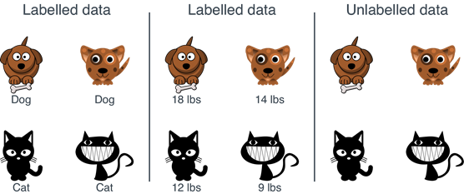

So what is then, supervised and unsupervised learning?

Clearly, it is better to have labeled data than unlabeled data. With a labeled dataset, we can do much more. But there are still many things that we can do with an unlabeled dataset.

The set of algorithms in which we use a labeled dataset is called *supervised learning*. The set of algorithms in which we use an unlabeled dataset, is called *unsupervised learning*. This is what we learn next.

**2.2 What is supervised learning?**

Supervised learning is the type of machine learning you find in the most common applications nowadays, including image recognition, various forms of text processing, recommendation systems, and many more. it is a type of predictive machine learning in which the data comes with labels, where the label is the target we are interested in predicting.

In the example on Figure 2.1, where the dataset is formed by images of dogs and cats, and the labels in the image are ‘dog’ and ‘cat’, the machine learning model would simply use previous data in order to predict the label of new data points. This means, if we bring in a new image *without* a label, the model would guess if the image is of a dog or a cat, thus predicting the label of the data point.

**Figure 2.2. A supervised learning model predicts the label of a new data point.**

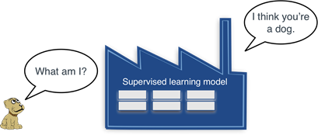

The framework for making a decision is Remember-Formulate-Predict. This is precisely how supervised learning works. The model first **remembers** the dataset of dogs and cats, then **formulates** a model, or a rule for what is a dog and what is a cat, and when a new image comes in, the model makes a **prediction** about what the label of the image is, namely, is it a dog or a cat.

**Figure 2.3. Supervised learning follows the Remember-Formulate-Predict framework.**

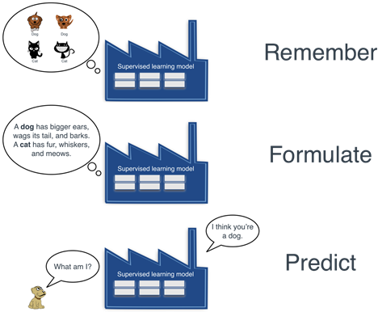

Now, notice that in Figure 2.1, we have two types of datasets, one in which the labels are numbers (the weight of the animal), and one in which the labels are states, or classes (the type of animal, namely cat or dog). This gives rise to two types of supervised learning models.

**Regression models:** These are the types of models that predict a **number**, such as the weight of the animal.

**Classification models:** These are the types of models that predict a **state**, such as the type of animal (cat or dog).

We call the output of a regression model *continuous*, since the prediction can be any real value, picked from a continuous interval. We call the output of a classification model *discrete*, since the prediction can be a value from a finite list. An interesting fact is that the output can be more than two states. If we had more states, say, a model that predicts if a picture is of a dog, a cat, or a bird, we can still use a discrete model. These models are called multivariate discrete models. There are classifiers with many states, but it must always be a finite number.

Let’s look at two examples of supervised learning models, one regression and one classification:

Example 1 (regression), housing prices model: In this model, each data point is a house. The label of each house is its price. Our goal is, when a new house (data point) comes in the market, we would like to predict its label, namely, its price.

Example 2 (classification), email spam detection model: In this model, each data point is an email. The label of each email is either spam or ham. Our goal is, when a new email (data point) comes into our inbox, we would like to predict its label, namely, if it is spam or ham.

You can see the difference between models 1 and 2.

* Example 1, the housing prices model, is a model that can return many numbers, such as $100, $250,000, or $3,125,672. Thus it is a *regression* model.
* Example 2, the spam detection model, on the other hand, can only return two things: spam or ham. Thus it is a *classification* model.

Let’s elaborate some more on regression and classification.

**2.2.1   Regression models predict numbers**

As we mentioned previously, regression models are those that predict a number. This number is predicted from the features. In the housing example, the features can be the size of the house, the number of rooms, the distance to the closest school, the crime rate in the neighborhood, etc.

Other places where one can use regression models are the following:

* Stock market: Predicting the price of a certain stock based on other stock prices, and other market signals.
* Medicine: Predicting the expected lifespan of a patient, or the expected recovery time, based on symptoms and the medical history of the patient.
* Sales: Predicting the expected amount of money a customer will spend, based on the client’s demographics and past purchase behavior.
* Video recommendations: Predicting the expected amount of time a user will watch a video, based on the user’s demographics and past interaction with the site.

The most common method used for regression is *linear regression*, which is when we use linear functions (basically lines) to make our predictions based on the features.

**2.2.2   Classification models predict a state**

Classification models are those that predict a state, from a finite set of states. The most common ones predict a ‘yes’ or a ‘no’, but there are many models which use a larger set of states. The example we saw in Figure 2.3 is of classification, as it predicts the type of the pet, namely, ‘cat’ or ‘dog’.

In the email spam recognition example, the state of the email (namely, is it spam or not) is predicted from the features. In this case, the features of the email are the words on it, the number of spelling mistakes, the sender, and many others.

Another very common example of classification is image recognition. The most popular image recognition models take as an input the pixels in the image, and output a prediction of what the image most likely depicts. Two of the most famous datasets for image recognition are MNIST and CIFAR-10. MNIST is formed by around 70,000 images of handwritten digits, which are classified as the digits 0-9. These images come from a combination of sources, including the American Census Bureau, and handwritten digits taken from American high school students. It can be found in the following link: http://yann.lecun.com/exdb/mnist/. CIFAR-10 is made of 60,000 32 by 32 colored images of different things. These are classified as 10 different classes (thus the 10 in the name), namely airplanes, cars, birds, cats, deer, dogs, frogs, horses, ships, and trucks. This database is maintained by the Canadian Institute For Advanced Research (CIFAR), and can be found in the following link: https://www.cs.toronto.edu/~kriz/cifar.html.

Other places where one can use classification models are the following:

* Sentiment analysis: Predicting if a movie review is positive or negative, based on the words in the review.
* Website traffic: Predicting if a user will click on a link or not, based on the user’s demographics and past interaction with the site.
* Social media: Predicting if a user will be friend or interact with another user or not, based on their demographics, history, and friends in common.

**2.3 What is unsupervised learning?**

Unsupervised learning is also a very common type of machine learning. It differs from supervised learning in that the data has no labels. What is a dataset with no labels, you ask? Well, it is a dataset with only features, and no target to predict. For example, if our housing dataset had no prices, then it would be an unlabeled dataset. If our emails dataset had no labels, then it would simply be a dataset of emails, where ‘spam’ and ‘no spam’ is not specified.

So what could you do with such a dataset? Well, a little less than with a labelled dataset, unfortunately, since the main thing we are aiming to predict is not there. However, we can still extract a lot of information from an unlabelled dataset. Here is an example, let us go back to the cats and dogs example in Figure 2.1. If our dataset has no labels, then we simply have a bunch of pictures of dogs and cats, and we do not know what type of pet each one represents. Our model can still tell us if two pictures of dogs are similar to each other, and different to a picture of a cat. Maybe it can group them in some way by similarity, even without knowing what each group represents.

**Figure 2.4. An unsupervised learning model can still extract information from data, for example, it can group similar elements together.**

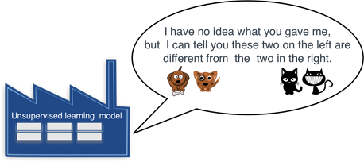

And the branch of machine learning that deals with unlabelled datasets is called *unsupervised machine learning*. As a matter of fact, even if the labels are there, we can still use unsupervised learning techniques on our data, in order to preprocess it and apply supervised learning methods much more effectively.

The two main branches of unsupervised learning are clustering and dimensionality reduction. They are defined as follows.

**Clustering:** This is the task of grouping our data into clusters based on similarity. (This is what we saw in Figure 2.4.)

**Dimensionality reduction:** This is the task of simplifying our data and describing it with fewer features, without losing much generality.

Let’s study them in more detail.

**2.3.1   Clustering algorithms split a dataset into similar groups**

As we stated previously, clustering algorithms are those that look at a dataset, and split it into similar groups

So let’s go back to our two examples. In the first one, we have a dataset with information about houses, but no prices. What could we do? Here is an idea: we could somehow group them into similar houses. We could group them by location, by price, by size, or by a combination of these factors. This is called *clustering*. Clustering is a branch of unsupervised machine learning which consists of grouping the elements in our dataset into clusters that are similar. Could we do that with other datasets?

Let’s look at our second example, the dataset of emails. Because the dataset is unlabeled, we don’t know if each email is spam or not. However, we can still apply some clustering to our dataset. A clustering algorithm will return our emails split into, say, 4 or 5 different categories, based on different features such as words in the message, sender, attachments, types of links on them, and more. It is then up to a human (or a supervised learning algorithm) to label categories such as ‘Personal’, ‘Social’, ‘Promotions’, and others.

For example, let’s say that we have 9 emails, and we want to cluster them into different types. We have, say, the size of the email, and the number of recipients. And the data looks like this, ordered by number of recipients:

**Table 2.5. A table of emails with their size and number of recipients.**

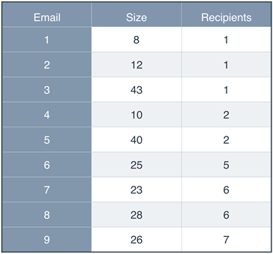

To the naked eye, it looks like we could group them by size, where the emails in one group would have 1 or 2 recipients, and the emails in the other group would have 5 or more recipients. We could also try to group them into three groups by size. But you can imagine that as the data gets larger and larger, eyeballing the groups gets harder and harder. What if we plot the data? Let’s plot the emails in a graph, where the horizontal axis records the size, and the vertical axis records the number of recipients. We get the following plot.

**Figure 2.6. A plot of the emails with size on the horizontal axis and number of recipients on the vertical axis. Eyeballing it, it is obvious that there are three distinct types of emails.**

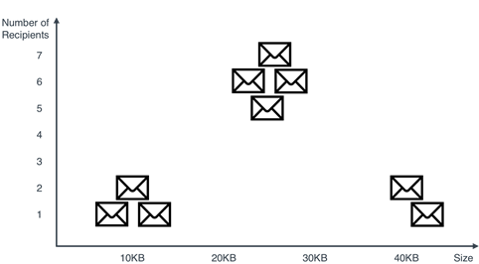

In Figure  2.6 we can see three groups, very well defined. We can make each a different category in our inbox. They are the ones we see in Figure 2.7.

**Figure 2.7. Clustering the emails into three categories based on size and number of recipients.**

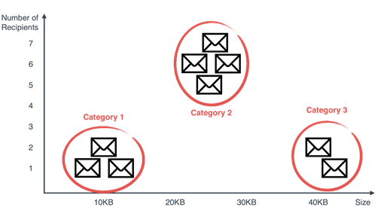

This last step is what clustering is all about. Of course, for us humans, it was very easy to eyeball the three groups once we have the plot. But for a computer, this is not easy. And furthermore, imagine if our data was formed by millions of points, with hundreds or thousands of columns. All of a sudden, we cannot eyeball the data, and clustering becomes hard. Luckily, computers can do these type of clustering for huge datasets with lots of columns.

Other applications of clustering are the following:

* Market segmentation: Dividing customers into groups based on demographic and purchasing (or engagement) behavior, in order to create different marketing strategies for the groups.
* Genetics: Clustering species into groups based on similarity.
* Medical imaging: Splitting an image into different parts in order to study different types of tissue.

**UNSUPERVISED LEARNING ALGORITHMS**

K-means clustering: This algorithm groups points by picking some random centers of mass, and moving them closer and closer to the points until they are at the right spots.

Hierarchical clustering: This algorithm starts by grouping the closest points together, and continuing in this fashion, until we have some well-defined groups.

Density-based special clustering (DBSCAN): This algorithm starts grouping points together in points of high density, while leaving the isolated points as noise.

Gaussian mixture models: This algorithm doesn’t actually determine if an element belongs to a cluster, but instead gives a breakdown of percentages. For example, if there are three clusters, A, B, and C, then the algorithm could say that a point belongs 60% to group A, 25% to group B, and 15% to group C.

**2.3.2   Dimensionality reduction simplifies data without losing much information**

Dimensionality reduction is a very useful preprocessing step which we can apply to vastly simplify our data, before applying other techniques. Let’s look at the housing example. Let’s say that we want to predict the price, and the features are the following:

1. Size.
2. Number of bedrooms.
3. Number of bathrooms.
4. Crime rate in the neighborhood.
5. Distance to the nearest school.

That is five columns of data. What if we wanted a simpler dataset, with fewer columns, but that can portray the information in as faithful a way as possible. Let’s do it using common sense. Take a closer look at the five features. Can you see any way to simplify them, maybe to group them into some smaller and more general categories?

After a careful look, maybe you thought the same as I did, which is: The first three features seem similar, and the fourth and fifth also seem similar. The first three are all related to the size of the house, whereas the fourth and fifth are related to the quality of the neighborhood. We could condense them into a big ‘size’ feature, and a big ‘area quality’ feature. How do we condense the size features? There are many ways, we could only consider the size, we could add the number of bedrooms and bathrooms, or maybe some linear combination of the three features. How do we condense the neighborhood quality features? Again in many ways, if they are both given by coefficients, we can add them, subtract them, etc. The dimensionality reduction algorithms will find ways that group them, losing as little information as possible, and keeping our data as intact as possible, while managing to simplify it for easier process and storage.

**Figure 2.8. Using dimensionality reduction to reduce the number of features in a housing dataset, without losing much information.**

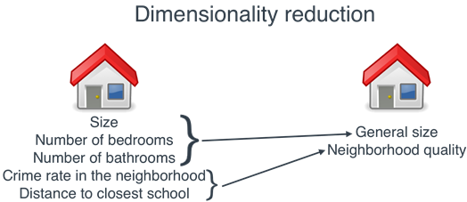

Now, why is it called dimensionality reduction, if all we’re doing is reducing the number of columns in our data? Well, the fancy word for *number of columns* in data is *dimension*. Think about this, if our data has one column, then each data point is one number. This is the same as if our data set was formed by points in a line, and a line has one dimension. If our data has two columns, then each data point is formed by two numbers. This is like coordinates in a city, where the first number is the street number, and the second number is the avenue. And cities are two dimensional, since they are in a plane (if we imagine that every house has only one floor. Now, what happens when our data has 3 columns? In this case, then each data point is formed by 3 numbers. We can imagine that if every address in our city is a building, then the first and second numbers are the street and avenue, and the third one is the floor in which we live in. This looks like a three-dimensional city. We can keep going. What about four numbers? Well, now we can’t really visualize it, but if we could, this would be addresses in a four-dimensional city, and so on. The best way I can imagine a four dimensional city, is by imagining a table of four columns.

Therefore, when we went from five dimensions down to two, we reduced our 5-dimensional city into a 2-dimensional city, thus applying dimensionality reduction.

**2.4 What is reinforcement learning?**

Reinforcement learning is a different type of machine learning, in which no data is given, and we must solve a problem. Instead of data, an environment is given, and an agent who is supposed to navigate in this environment. The agent has a goal, or a set of goals. The environment has rewards and punishments, which guide the agent to take the right decisions in order to reach its goal. That all sounded a bit abstract, but let’s look at some examples.

Example 1: Grid world

In Figure 2.10 we see a grid world with a robot on the bottom left corner. That is our agent. The goal is to get to the treasure chest in the top right of the grid. In the grid, we can also see a mountain, which means we cannot go through that square, since the robot cannot climb mountains. We also see a dragon, which will attack the robot, should the robot dare to land in the square of the dragon, so part of our goal is to not land over there. This is the game. And in order to give the robot information about how to proceed, we have a score. The score starts at zero. If we get to the treasure chest, then we gain 100 points. If we reach the dragon, we lose 50 points. And to make things fast, let’s say that for every step the robot makes, we lose 1 point, since the robot loses energy.

**Figure 2.10. A grid world in which our agent is a robot. The goal of the robot is to find the treasure chest, while avoiding the dragon. The mountain represents a place in which the robot can’t pass through.**

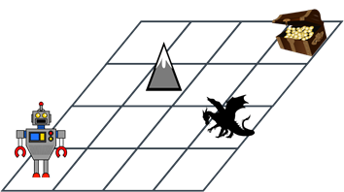

The way to train this algorithm, in very rough terms, is as follows. The robot starts walking around, recording its score, and remembering what steps took it to each decision. After some point, it may meet the dragon, losing many points. Therefore, it learns that the dragon square, and squares close to it, are associated to low scores. At some point it may also hit the treasure chest, and it starts associating that square, and squares close to it, to high scores. Eventually, the robot will have a good idea of how good each square is, and can take the path following the squares all the way to the chest. Figure 2.11 shows a possible path, although this one is not ideal, since it passes close to the dragon. Can you think of a better one?

**Figure 2.11. Here is a path that the robot could take to find the treasure chest.**

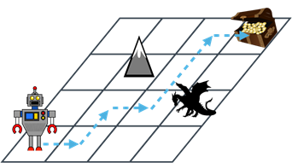

Now, of course this was a very brief explanation, and there is a lot more to this. Anytime you have an agent navigating an environment, picking up information and learning how to get rewards and avoid punishment, you have reinforcement learning.

Reinforcement learning has numerous cutting edge applications, and here are some of them.

* Games: The recent advances teaching computers how to win at games such as chess, use reinforcement learning.
* Robotics: Reinforcement learning is used extensively to help robots do tasks such as picking up boxes, cleaning a room, or any similar actions.
* Self driving cars: For anything from path planning to controlling the car, reinforcement learning techniques are used.

**2.5 Summary**

* There are several types of machine learning, including supervised learning and unsupervised learning.
* Supervised learning is used on labelled data, and it is good for making predictions.
* Unsupervised learning is used on unlabelled data, and it is normally used as a preprocessing step.
* Two very common types of supervised learning algorithms are called regression and classification.
* Regression models are those in which the answer is any number.
* Classification models are those in which the answer is of a type yes/no. The answer is normally given as a number between 0 and 1, denoting a probability.
* Two very common types of unsupervised learning algorithms are clustering and dimensionality reduction.
* Clustering is used to group our data into similar clusters, in order to extract information, or make it easier to handle.
* Dimensionality reduction is a way to simplify our data, by joining certain similar features and losing as little information as possible.
* Reinforcement learning is a type of machine learning used where an agent has to navigate an environment and reach a goal. It is extensively used in many cutting edge applications.